**Introduction to Databases**

**CA1 - 20/11/22**

**Denis Murray - X22154043**

**Part 1: Conceptual Design:**

**Exercise 1**

I have decided to model this CA around a Supermarket. A supermarket uses a database to record daily transactions along with many other pieces of data. Daily transactions are stored in the OrderDetails table.

Customer information is stored to track spending and purchasing habits. Customers can sign up for a loyalty card which is connected to their customerID number. Special offers can be offered to these customers to encourage return shoppers. The supermarket can also get in touch with the customer to update them with any upcoming products that might interest them.

Employee data is also maintained in the database. Storing each employees information allows the supermarket to get in touch with the employee if there is any need to do so, for example if the employee has not made it to work that day. Employee positions are also important to be stored in the database as any changing of positions needs to be updated for payroll.

Supplier data is stored to ensure that suppliers are paid the correct agreed upon amount and to ensure relations between supermarket and suppliers are maintained. What products come from which suppliers and product amounts are extremely important to keep a record of to ensure waste is kept to a minimum.

Product data is stored to ensure prices are tracked and sales numbers can be tracked. Maintaining a record of each individual product is incredibly important for stock reasons and balancing budgets and is very helpful to identify which products are selling well and making profits for the supermarket.

Department info is tracked to ensure that the supermarket can identify which departments are performing well and whether a department is staffed correctly. Without this information the supermarket could be losing profits without realising due to short staffing, under stocking or incorrectly stocking departments.

Order information is incredibly important to store for the supermarket. By storing each order information, the supermarket can see exactly how many transactions were completed on a daily basis. Customers can return products by returning a receipt of the order.

**Exercise 2**

Conceptual ERD

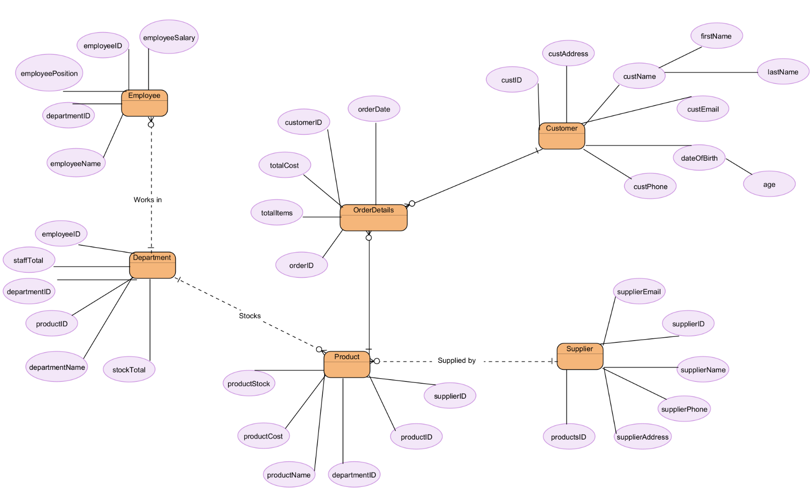

Derived attributes:

* firstName and lastName attributes of the Customer entity are derived from the name attribute
* age attribute of the Customer entity is derived from the dateOfBirth attribute

Relational Model

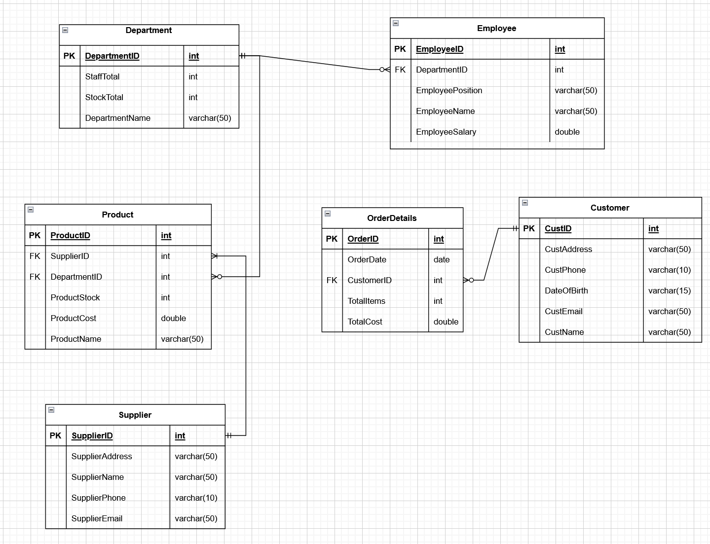

**Part 2: Physical Design**

(All SQL queries executed using SQLiteStudio)

**Exercise 1**

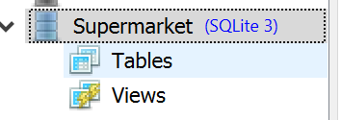Creating the database:

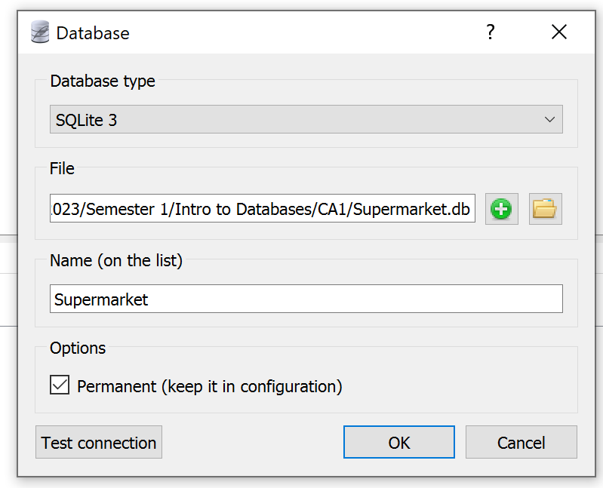

**Exercise 2**

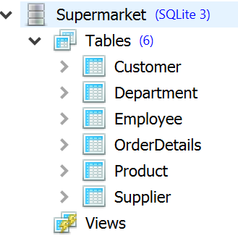

**Exercise 3**

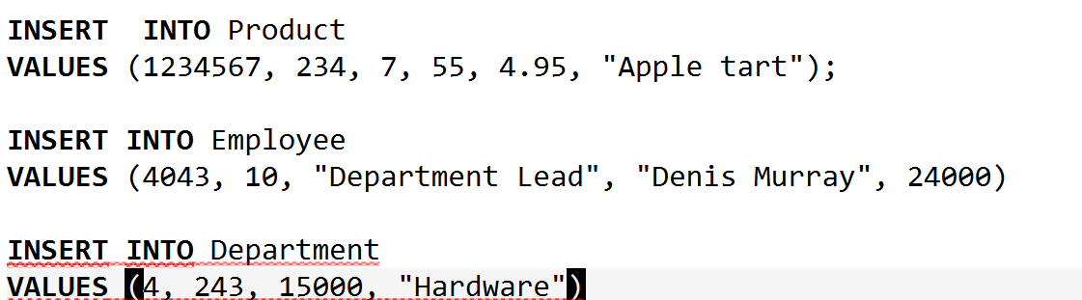

**Exercise 4**

I used Mockaroo to generate the data for the database. Please see the attached Denis_Murray_SQL.sql file for the sql statements generated for this exercise or follow the links for schemas used:

* <https://www.mockaroo.com/cb711360>
* <https://www.mockaroo.com/66fdf1c0>
* <https://www.mockaroo.com/06e3bb30>
* <https://www.mockaroo.com/437c9350>
* <https://www.mockaroo.com/a21601f0>
* <https://www.mockaroo.com/2f5a1570>

**Part 3: Write SQL Statements to answer queries**

**Exercise 1**

**All transactions:**

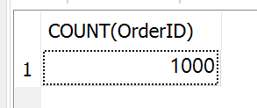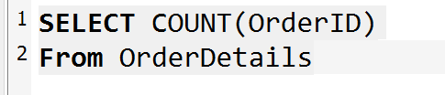= 1000 transactions for the year

**Customer with highest number of purchases:**

= 6 CustomerID’s with 12 purchases each.

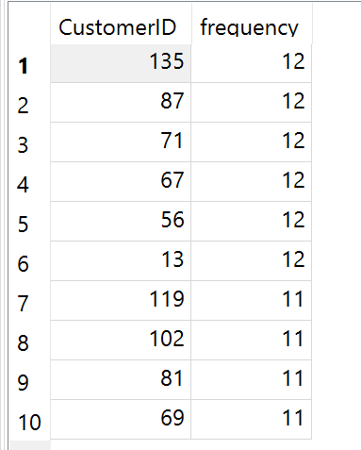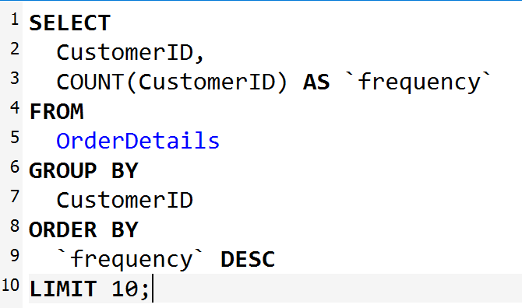

**Exercise 2**

**Includes “Order By” and “Grouped By”**

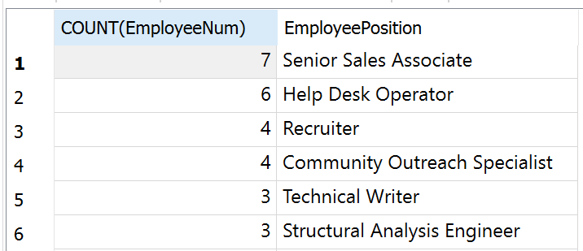Counting most staffed position in the company, ordered from most staffed position to least staffed position:

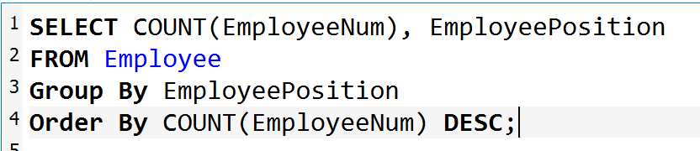

**Exercise 3**

**Pattern matching**

Query to find all Customers in Customer table that start with the letter “d”:

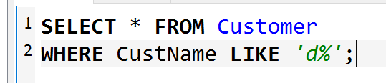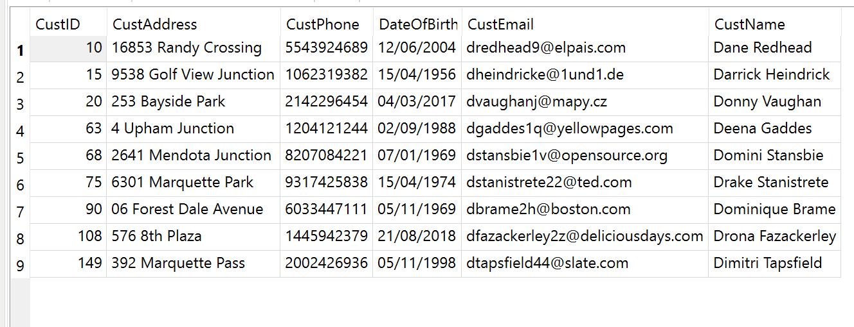

**Exercise 4**

**Show information from three tables**

Showing SupplierName from Supplier table, DepartmentName from Department table, and ProductID and ProductName from the Product table. (Ordered by supplier). This shows the products offered by which suppliers and in which department they are found:

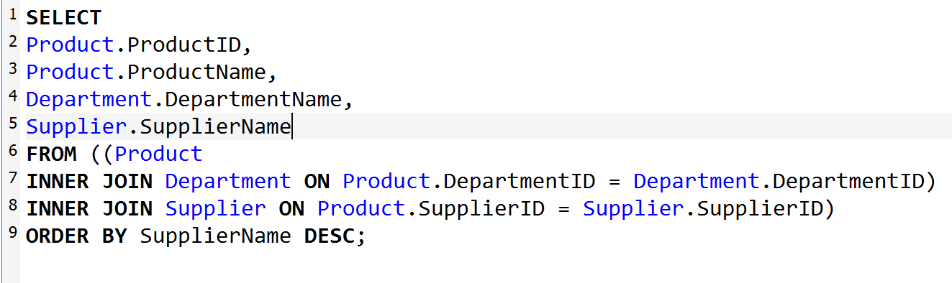

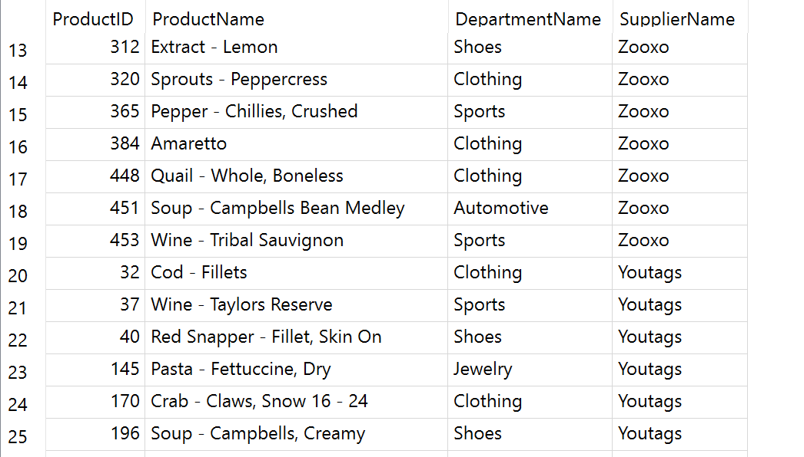

**Exercise 5**

**Information from the most frequent transactions (Customer names)**

View contains the names, emails, ID’s and phone numbers of the top 7 customers with the most transactions over the year:

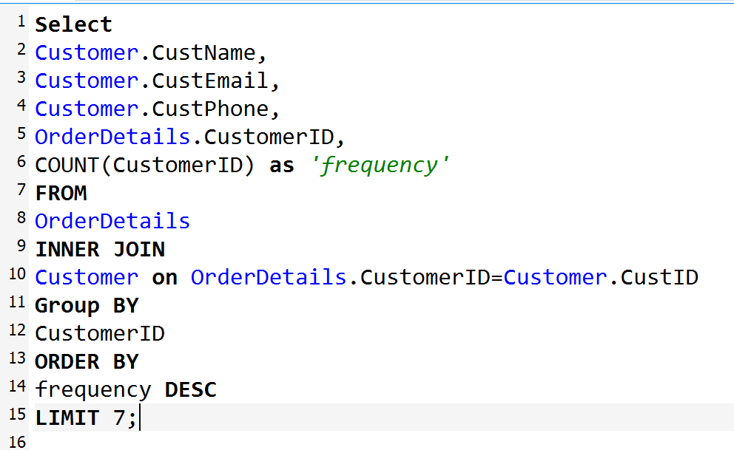

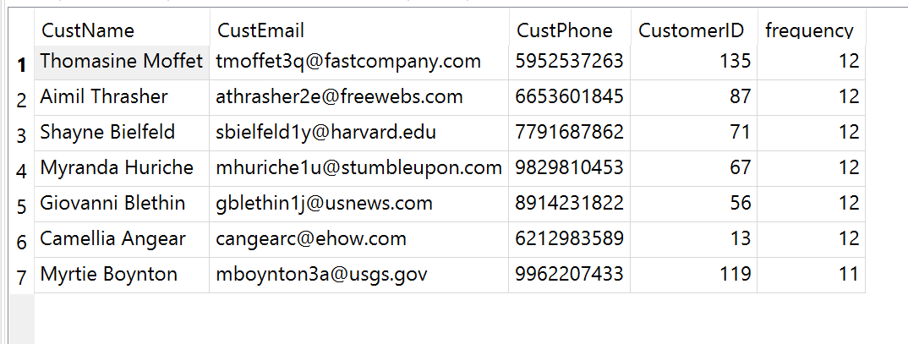

**Exercise 6**

**Transactions sorted from start of the year:**



**Customers sorted by most frequent shoppers, diplaying customer info and TotalItems purchased for the year:**

